**Computer Networks (CS –577) Spring 2022 Final Term: BS(CS/SE/IT)**

**Maximum Marks: 20 (Practical) Time: 45 Minutes**

Note: Attempt all questions in any order, but ensure their parts are attempted successively.

Be specific in your answers, draw diagrams if necessary.

**Q.1:**  **[07+06 Marks]**

**(a) Consider the given network and configure all devices using the given IP address. All the router interfaces should be up and running. The configuration should be done in a way that computer PC 0&1 can ping computer PC 2 & 3. Also write the response of *ping* sent by the destination to source.**

**(b) Using the same scenario show the routing table of each router after configuration.**

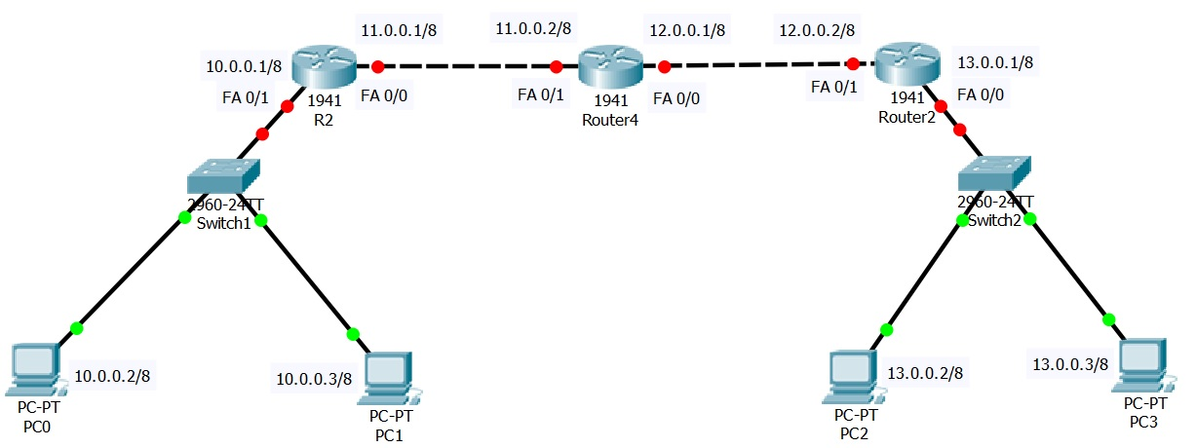

Router1

**Q.2: Describe the network design of your semester project (4 lines Max.)** [**07 Marks]**